Employee database

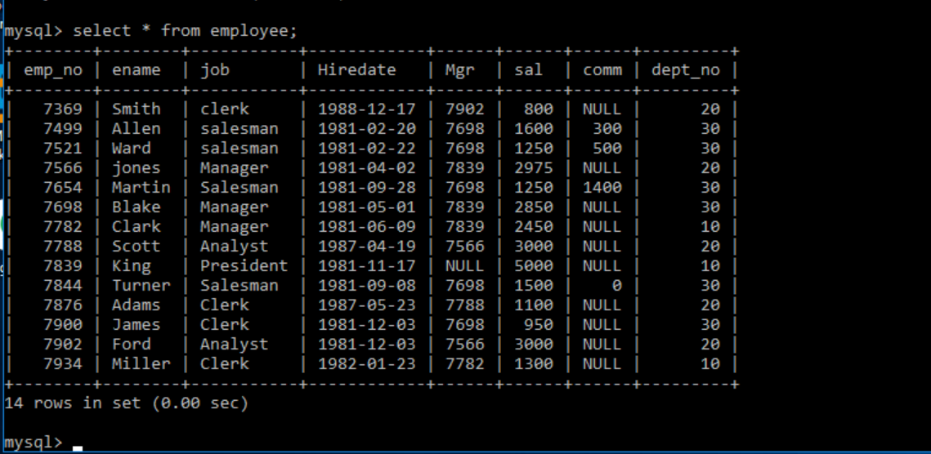

9. Find all the employees whose designation is either manager or president.



10.find all managers who are not in department 30.

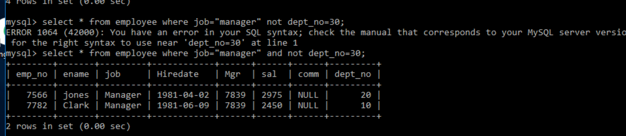

11.find all the details of managers and clerks in dept 10.

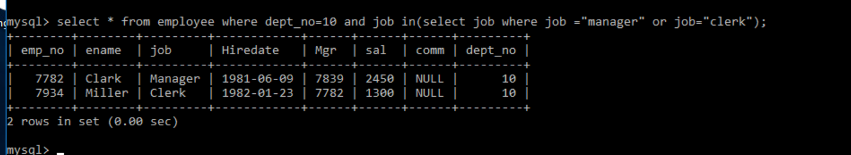

12.find all the details of all the managers (in any dept) and clerks in dept 20.



13.find the details of all the managers in dept 10 and all clerks in dept 20 and all employees who are neither managers not clerks but whose salary is more than or equal to2000.

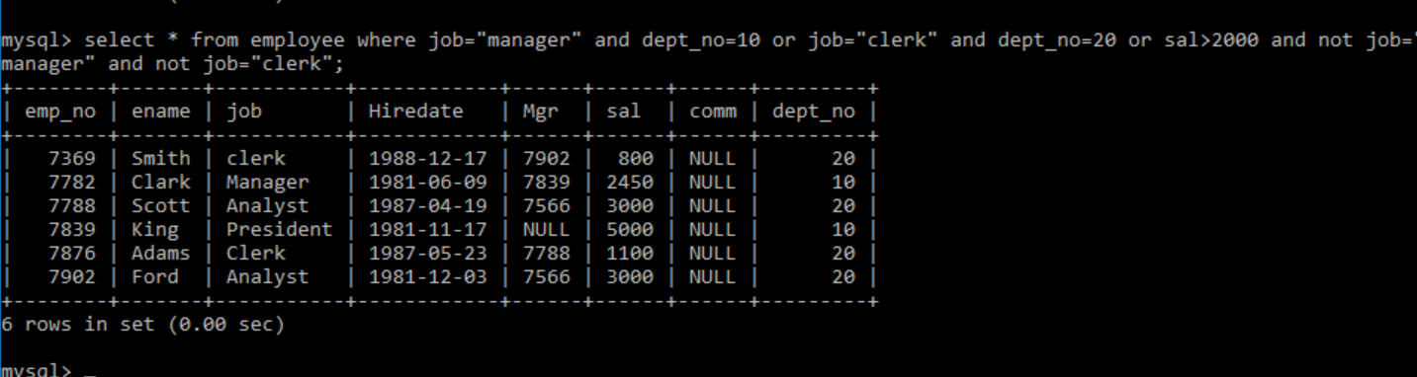

14.find the names of anyone in dept 20 who is neither manager nor clerk.



15.find the names of employees who earn between 1200 and 1400.

